**Building Chatbot And Integrate To Application**

|  |  |
| --- | --- |
| **Date** | 09 November 2022 |
| **Team ID** | PNT2022TMID50435 |
| **Project Name** | Smart Fashion Recommender Application |

# BUILDING CHATBOT:

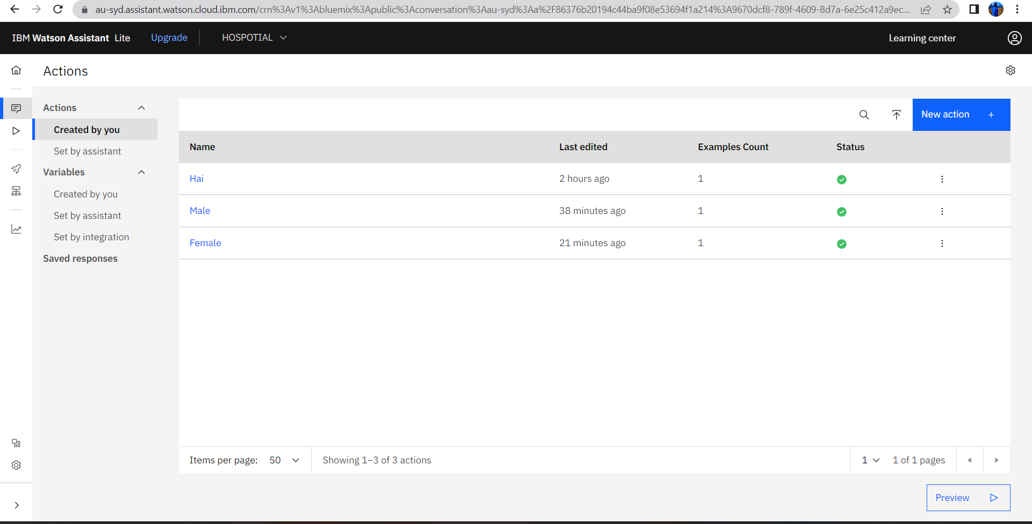

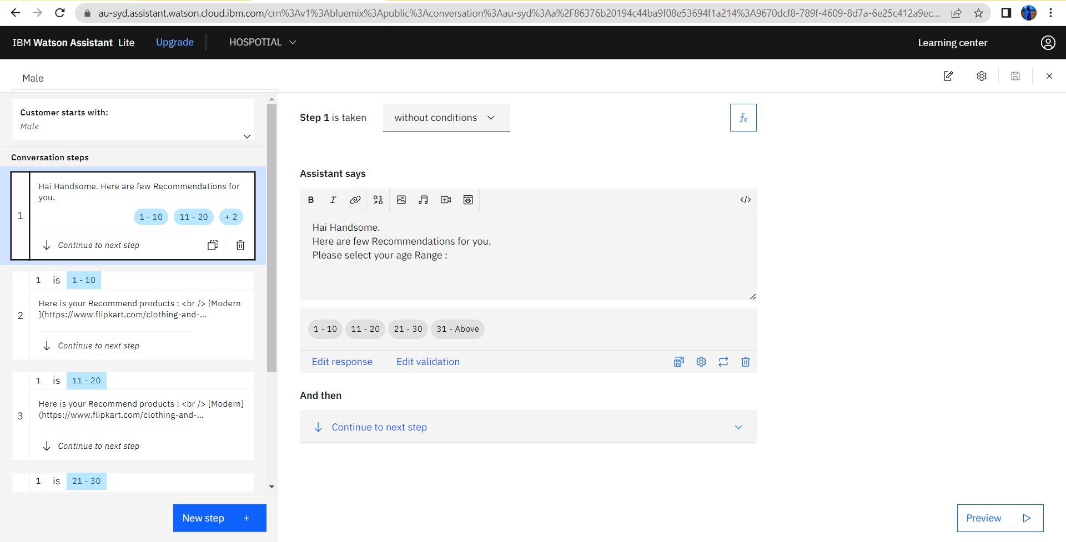

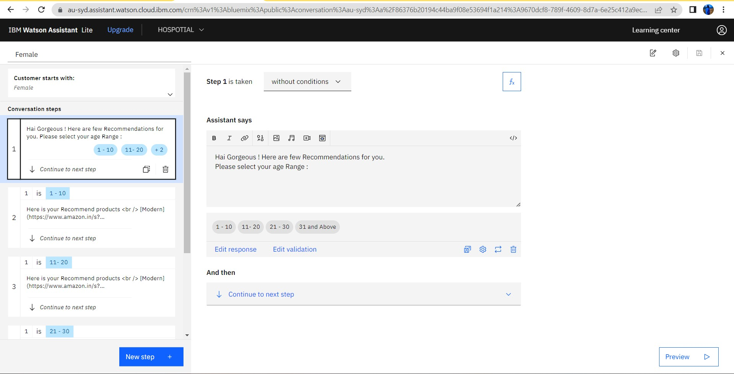

**CHATBOT INTEGRATION:**

<script> window.watsonAssistantChatOptions = {

integrationID: "614a4315-ff80-4187-8fe4-2fd9b506b723", // The ID of this integration. region: "au-syd", // The region your integration is hosted in.

serviceInstanceID: "9670dcf8-789f-4609-8d7a-6e25c412a9ec", // The ID of your service instance. onLoad: function(instance) { instance.render(); }

};

setTimeout(function(){

const t=document.createElement('script');

t.src="https://web-chat.global.assistant.watson.appdomain.cloud/versions/" + (window.watsonAssistantChatOptions.clientVersion || 'latest') + "/WatsonAssistantChatEntry.js";

document.head.appendChild(t);

});

</script>

# CHATBOT:

